CIS 634 Object-Oriented Software Engineering

# Software Requirements Specification

**Project Title: Power Management System**



Instructor: Prof. Weidong Xiong Group Number: 7

Group Members:

Tapan Desai CSU ID: 2777437 Shaishav Shah CSU ID: 2835285 Kinjal Patel CSU ID: 2794458

Mitee Patel CSU ID: 2817313

## Introduction

- Power Management System is a web application project which will monitor and manage the electricity usage of customers, calculate real-time units used & due billable amount, provide administration functionalities for admins to handle the management of bills, and provide payment gateway for final payment for the bills.

## 1.1 Goals and objectives

* + - The major goal of this project is to provide a desktop web application capable of managing and paying bills considering both the customer and administration perspectives.
    - To Achieve the goal, we will be using Java Language as its platform Independent Java is object-oriented. This allows you to create modular programs and reusable code.
    - Additionally, OOPs concepts are also being kept in mind while developing this web application. Considering this, the project will use Java programming language for back- end development of the project.
    - The Front end would be designed in HTML+CSS. Using HTML would be easy as well as compatible to the system as we can convert the Designed UI from CorelDraw or any other designing platform easily.
    - For database, we would be using MY SQL.
    - Under Java, we would be using Spring Boot framework as it is s build applications with ease and with far less toil than other competing paradigms.

## Statement of Scope

* + - For the customer side, the customer will be able to log in into the system, view the customer panel, look up his/her electricity usage, pay the pending bills, and look up previous bills.
    - For the admin side, the administrative personnel will be able to log in into the system, view the admin panel, locate all the customers and their billing history, view all payment deadlines, and manage all bill payment activities.
    - The admin can also keep track of customer records and alter units used.

## Major Constraints

* + - The main constraint for this project will be that as we don’t have access to get all the actual bill data from an existing database. So, we will instead work with dummy data inputted by ourselves for this project.
    - We also would have only the payment gateway, but no actual payment would be processed.

## Usage Scenario

* To log-in for both Customers as well as Admins, they need username and password. The customer ID should have their house number for tracking information easily. Passwords can be changed by the individual but for initial version it can include ethe last name and their DOB.

## User Profiles

* Our Project only has local user profiles.
* The user’s profiles would have address, phone number, Customer ID, etc information that is manually entered by us.
* The Unique key is the customer ID which has the last name of the user and the house number.

## Use Case Diagram

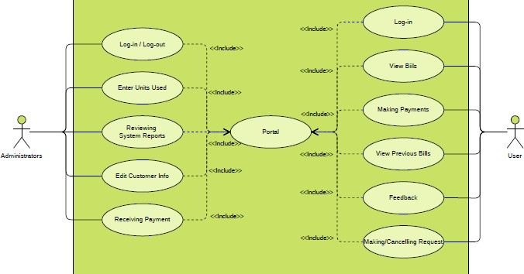

* 1. **Special usage considerations**
* This is a prototype project.
* There is only a payment-gateway, but no payment is processed.
* The Units are manually entered directly into database.

## Data Model and Description

* 1. **Data Description**
* The fields that will be manipulated by the administrator are Units used, Customer I information and Bill payment confirmation.
* The fields that will be manipulated by the customer will be Bill Payment mode and viewing previous bills.

## Complete Data Model

1. User Side

1. Admin Side

**3.3 Data Dictionary**

|  |  |
| --- | --- |
| Table Name | Customer |
| Field Name | Type |
| id | integer |
| meterno | integer |
| consumerno | biginteger |
| consumername | varchar() |
| load_con | varchar() |
| month | varchar() |
| year | integer |
| email | varchar() |
| address | text |
| amountgen | decimal |
|  | |
| Table | Admin |
| Field Name | Type |
| Id | Int |
| Name | varchar() |
| Password | varchar() |
| email | varchar() |

|  |  |
| --- | --- |
| Table | Login |
| Field Name | Type |
| id | int |
| userid | varchar() |
| branch | text |
| session_in | datetime |
| session_out | datetime |
|  | |
| Table | Bill |
| Field Name | Type |
| bill_id | int |
| bill_date | datetime |
| duedate | datetime |
| amount | Int |
| units | Int |
| status | varchar() |

**4.Functional Model and Description**

* 1. **Requirements:**

Admin:

* + 1. Login:
* Username & Password fields and login button will be on this page, through which admin will be able to login into the system.
* Forget password link will be there, which will redirect admin to the forget password page.
  + 1. Forget Password:
* Email id will be asked here through which new temporary password will be generated for the admin.
  + 1. Admin Home Page:
* Admin will be able to see all the users of the system listed on this page, along with view user details button. Filters will be there through which admin will be able to filter out the results.
  + 1. View User Details Page:
* Admin will be able to view a particular user’s details like user name, address, email, units used, all bills of that users on this page.
  + 1. View Bills Page:
* All bills of the system will be listed here. Filters will be there through which admin will be able to filter out the results.
* View Bill Details button will be displayed here in the list.
* For due bills, there will be a button called Send Due Warning.
  + 1. View Bill Details Page:
* Admin will be able to view a particular bill detail on this page like bill amount, user, due date, bill paid or not, along with edit bill button.
  + 1. Edit Bill Page:
* Admin will be able to edit bill details of the selected bill here.
  + 1. Bill Due Warning Page:
* After admin clicks on the Send Due Warning button, the result of the execution will be displayed on this page, along with the ability to view if the user responded to the warning or not.
  + 1. View Complaints Page:
* Admin will be able to see all the complaints listed here, along with View Complaint details button.
  + 1. Complaint Details Page:
* The details of the complaint will be displayed here like complaint id, details, user details, screenshot, along with a button Complaint Resolved button, through which admin can indicate to the user that that complaint has been resolved.

**Functionalities**

The most unique functionality of the project is that it encrypts the password once the user registers. Thus, even the admin cannot view the password.

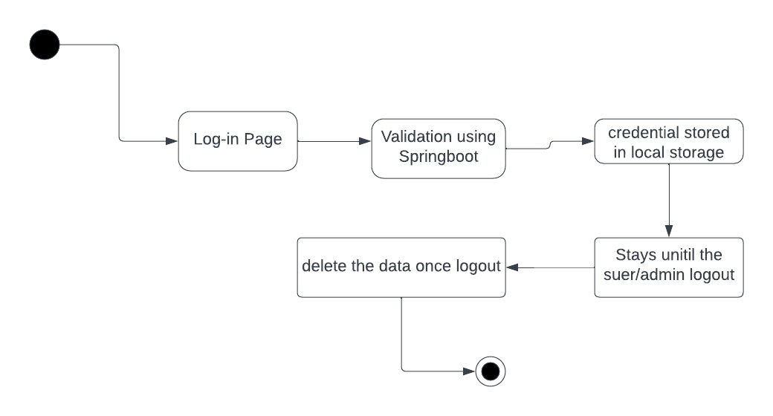

User:

1. Registration:

* User will be able to register for the account here.

1. Login:

* Username & Password fields and login button will be on this page, through which user will be able to login into the system.
* Forget password link will be there, which will redirect user to the forget password page.

1. Forget Password:

* Email id will be asked here through which new temporary password will be generated for the user.

1. User Home Page:

* User will be able to see all the bills of the user listed on this page, along with view bill details button. Filters will be there through which user will be able to filter out the results.

1. View User Details Page: User will be able to view the user’s details like user name, address, email, units used, view bills button on this page, along with edit details button.
2. Edit User Details Page:

* User will be able edit all his/her details here.

1. View Bills Page:

* All bills of the user will be displayed here along with filters to filter out the data.

1. View Bill Details Page:

* Bill details will be displayed here.

1. Bill Payment Page:

* Payment functionality will be on this page.

1. Complaint Registration Page:

* Complaints can be registered on this page.

## Software Interface Description

**-** The Software main purpose is to deliver a simple yet efficient model to not only serve the customer but also simplify the administrators work.

- So, to do that we need the web app to have very simple interface. The Log-in page should be common for customer and as well as administrators.

## Restrictions, Limitations, and Constraints

* + 1. **Restrictions**
       - A constant Internet Connection is required.
       - The database of the consumer must be constantly updated by the admin every month through csv files.
       - And in the customers or consumer portal in case of any emergency or help requiring situation one cannot contact any authority as would be required to resolve the problem in hand.